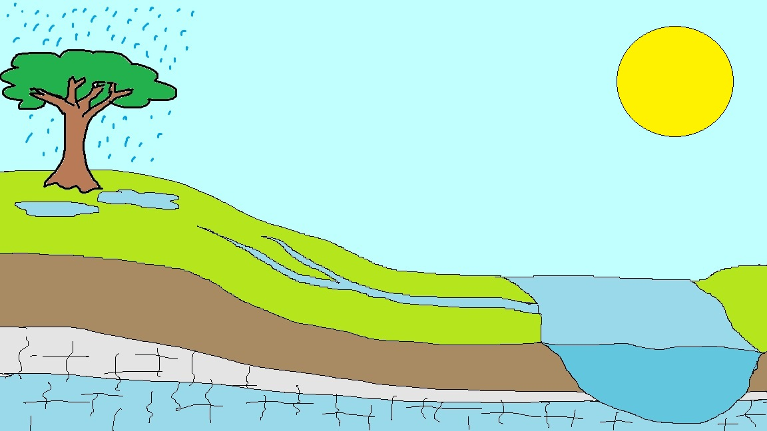

Rock

Key:

Output

Store

Input

Flow

Leads to the sea

Grass

Soil

Rock