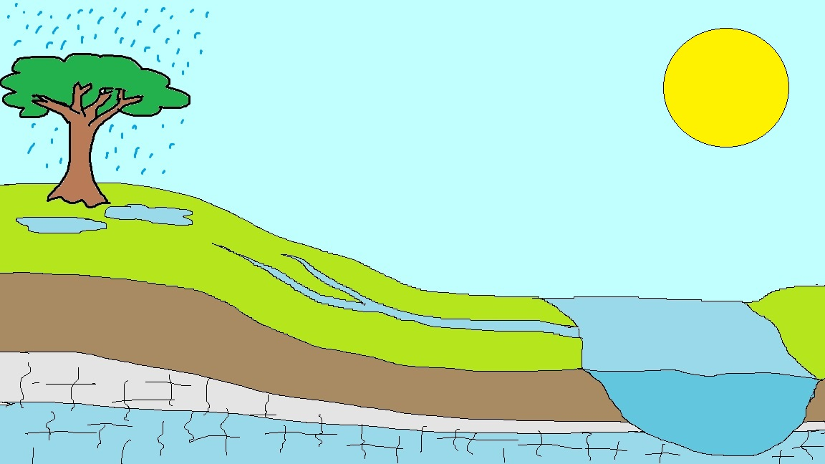

Throughflow

Surface Storage

Interception

Rock

Key:

Output

Store

Input

Flow

Leads to the sea

Grass

Surface Runoff

Soil

Rock

River Channel

Groundwater

Soil Moisture

Percolation

Infiltration

Groundwater Flow

Evaporation

Transpiration

Precipitation